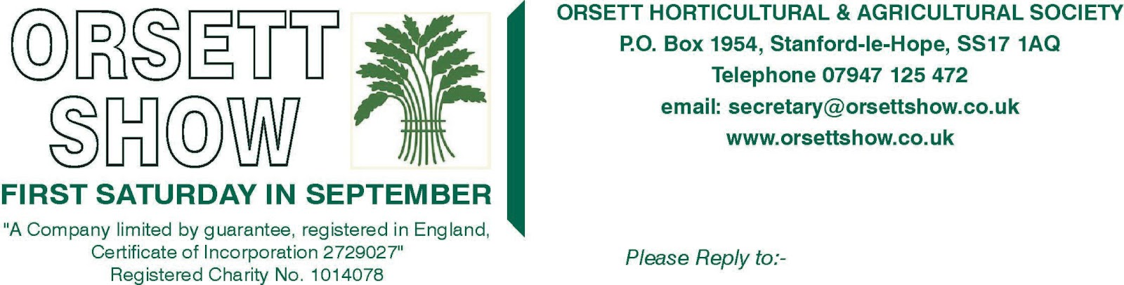

The Orsett Show Show Jumping Championship 2025
Saturday, 6th September 2025
The Orsett Showground, Rectory Rd, Orsett, Grays, Essex RM16 3JU
This championship is open to amateur competitors who qualify through shows hosted by approved venues.
How to Qualify:
To qualify for the championship, each partnership (horse and rider) must earn two qualifications by placing 1st-3rd in their relevant classes at any of the approved venues. A list of qualifying venues can be found on our website.
Registration Process:
To register your qualification, please visit www.orsettshow.co.uk/horse-section and click on the "Register My Qualification" tab. You will need to complete the horse and rider details and attach images of the results, which MUST include the placing, venue, class, and date. Please note, you cannot register until both qualifying results have been obtained.
We look forward to seeing you in September!
For more information, please email horsesection@orsettshow.co.uk or visit www.orsettshow.co.uk/horse-section.

Important Notes:
- You are not required to obtain your qualifications at the same venue—any two qualifications from any approved venue are accepted.
- You do not need to be a member to enter the championship.
- The last qualifying shows will take place on 25th August 2025, and entries close at midnight on Tuesday, 26th August 2025.
- No entries will be accepted on the day of the championship.
- Some classes may be spilt
- 1st to 6th place in each championship class will receive a championship rosette, with the champion & reserve champion receiving a sash.

The following classes will be qualifiers.

Height | Section
50cm | Horse/Pony
60cm | Horse/Pony
70cm | Horse/Pony
80cm | Horse/Pony
90cm | Horse/Pony

1st to 6 th place in each championship class will receive a championship rosette, with the champion & reserve champion receiving a sash and £15 & £10 prize money respectively.

